**Employee Notification**  
1. Pre-boarding is not available for applicants until 5 days prior to their start date. All employee’s pre-boarding must be completed before the end of their first day of employment.

2. Applicants will receive an automated email from NewHireAdmin with instructions to access Pre-boarding through the Careers Website, the day they are keyed by S & R into PS.   
 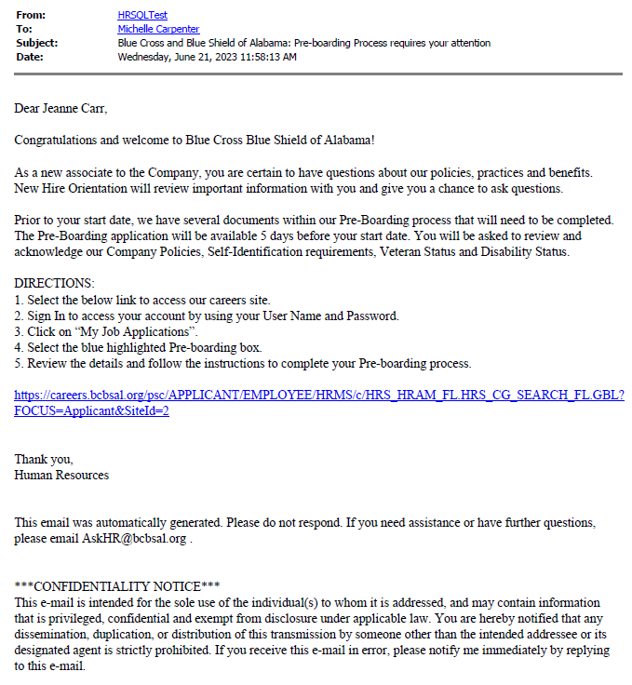  
  
3. Applicants will also receive another automated reminder email from NewHireAdmin on the Friday and Sunday before their start date.   
  
 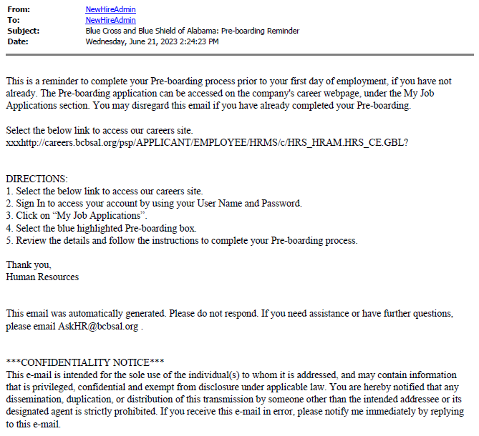

**How to Review Pre-boarding Status**1. To review the pre-boarding status of new hires, navigate to the below PS page and type in the start date and click search.   
 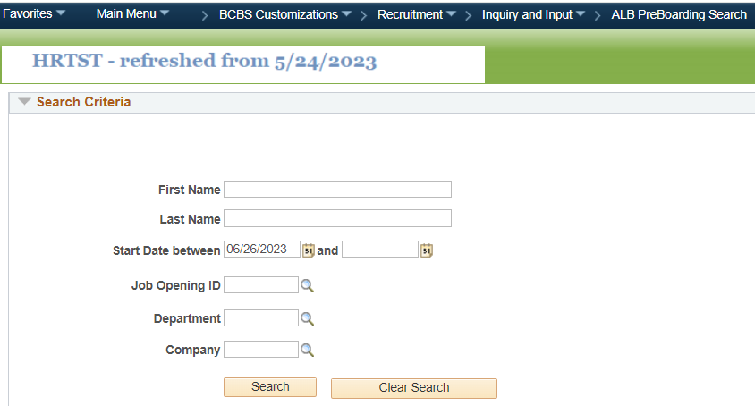

2. A list will populate that shows all news hires and the status of their pre-boarding program. If you click on the “View Pre-boarding” button, you can view the actual pages of that specific’s employee’s pre-boarding.   
 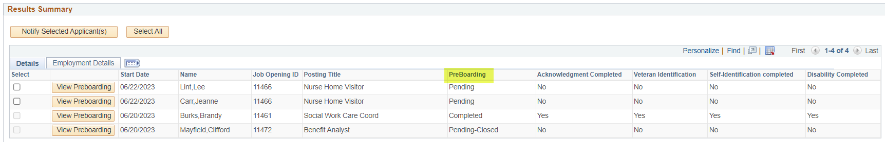

3. If you need to send additional reminders, other than the ones automatically sent on Friday and Sunday simply click on the box beside the associate’s name and then hit the “Notify Selected Applicant(s)”. They will receive the exact reminder email from above.   
 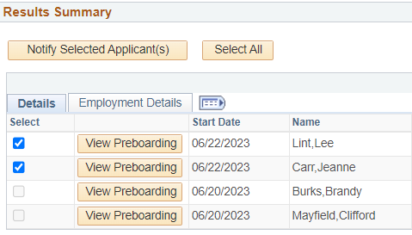

**\*\*NOTE**  
Employees enter pre-boarding from the Careers Website page shown below. You will enter Pre-boarding directly through the PS page.**

**Employee View of Pre-boarding**   
  
1. Employee will login with the same credentials they created when applying for the job.   
 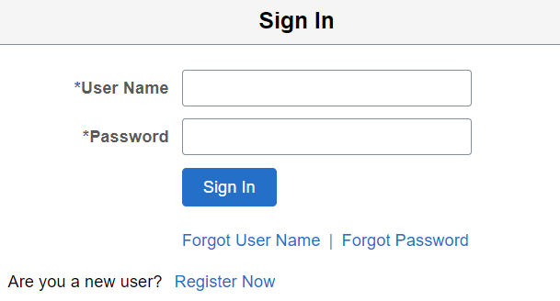

2. Employee will click on “My Job Applications”.  
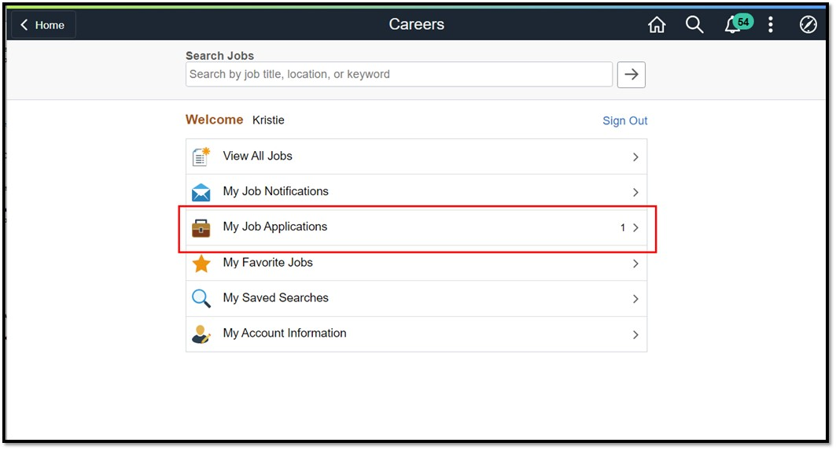

3. A new page will open and a blue pre-boarding button should be available to click. If the button is not there make sure they are within the 5 days (Thursday before) prior to their start date.

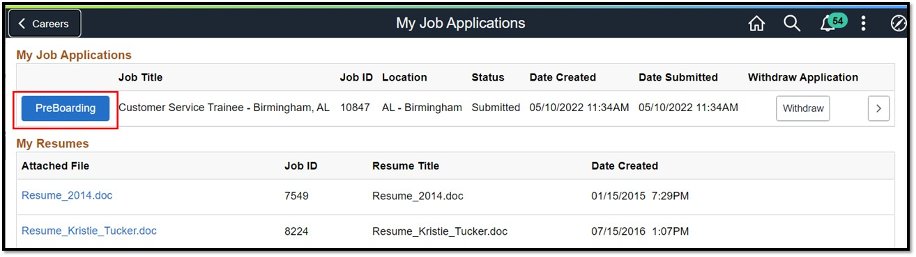

4. The employee is to complete all the below pages.  
 a. Welcome Page  
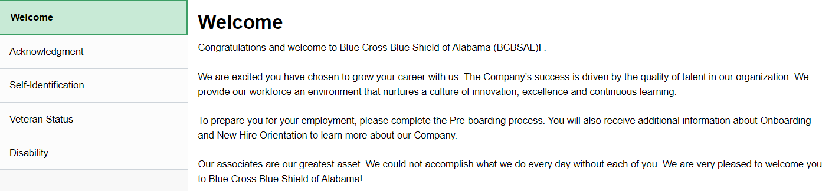  
 b. Acknowledgment Page   
 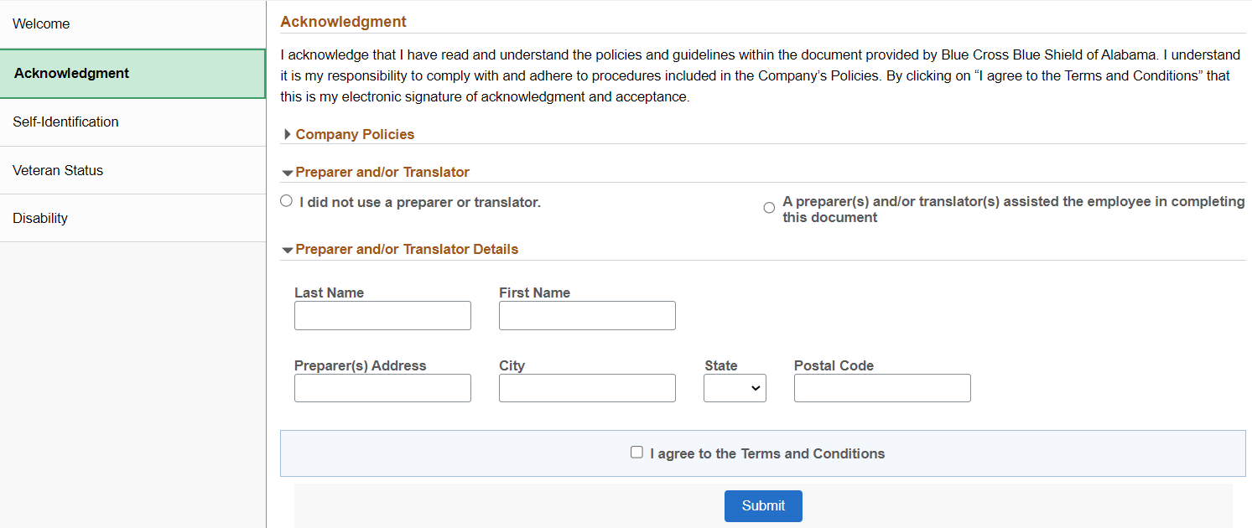

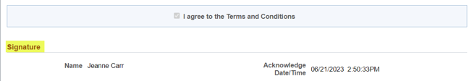

c. Self-Identification Page  
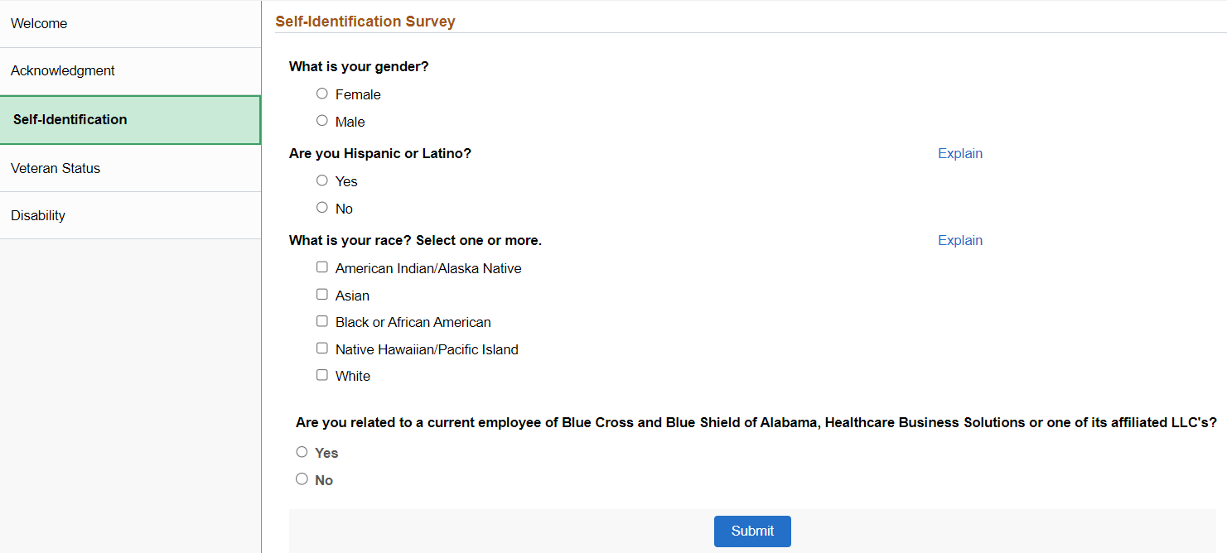

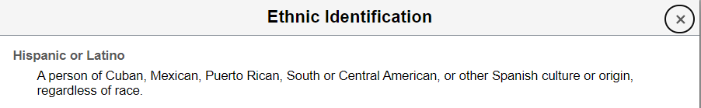

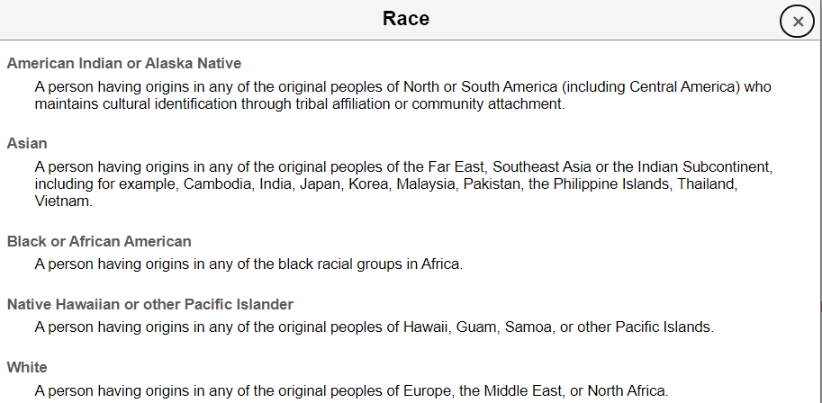

d. Veteran Status  
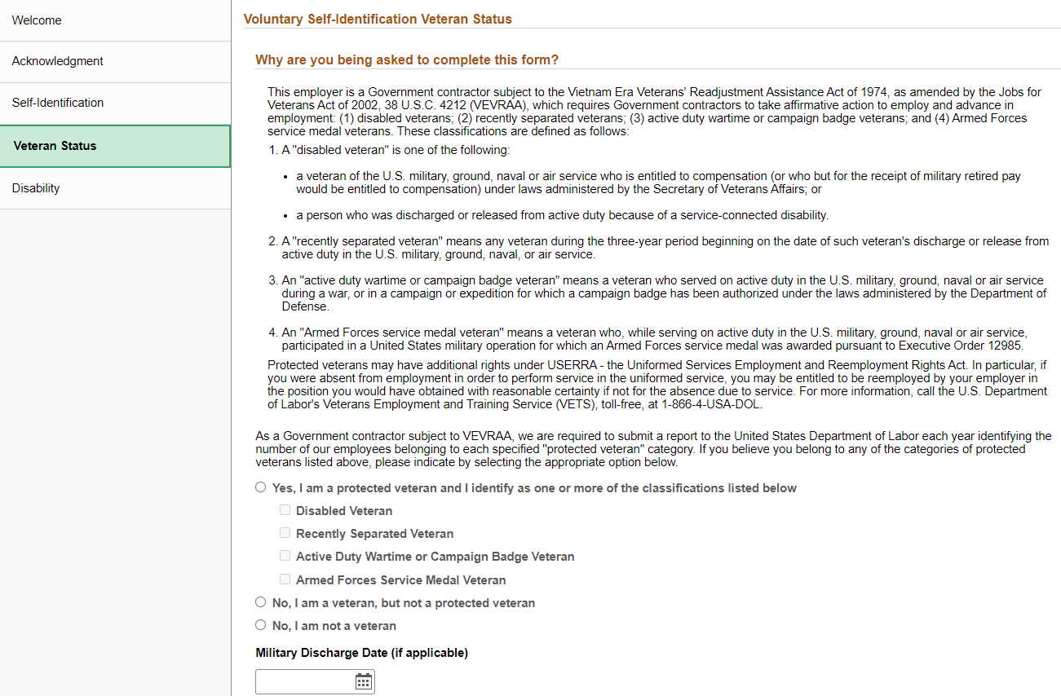  
e. Disability Page  
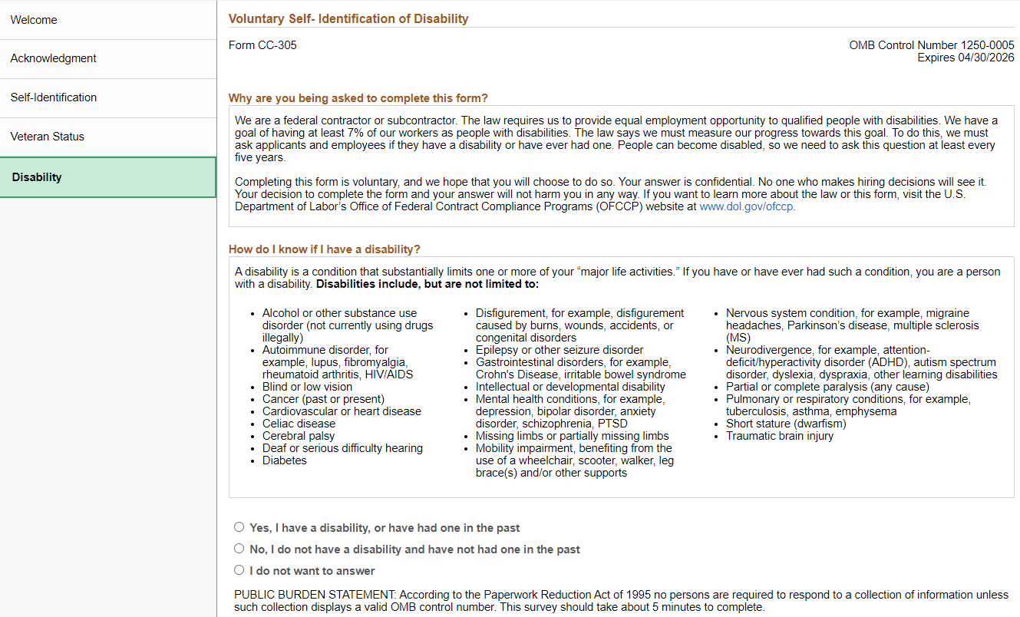

5. Potential Error Messages

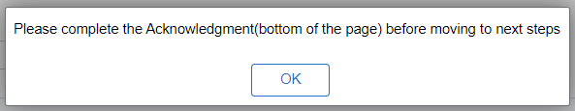  
  
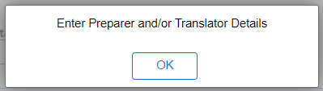 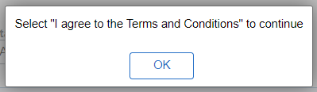

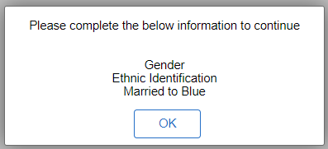 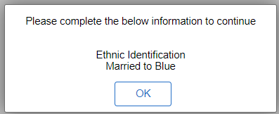

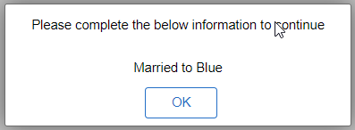 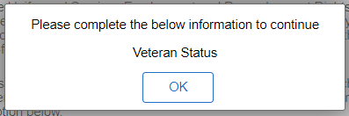

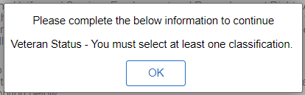 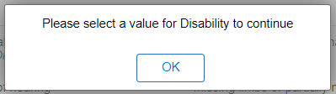

**Verifying Data in PS**  
  
1. Gender

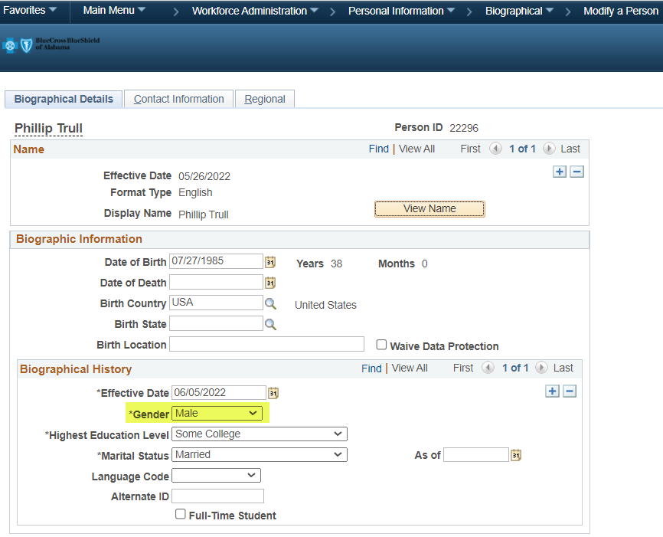2. Ethnicity, Race, Veteran Status  
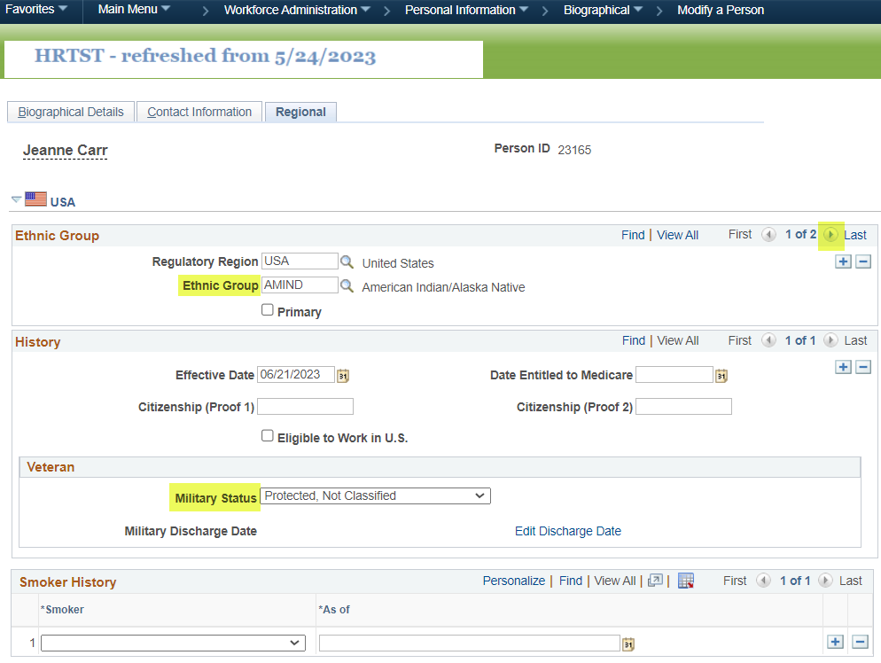

5. Preparer Information is not stored in PS

6. Married to Blue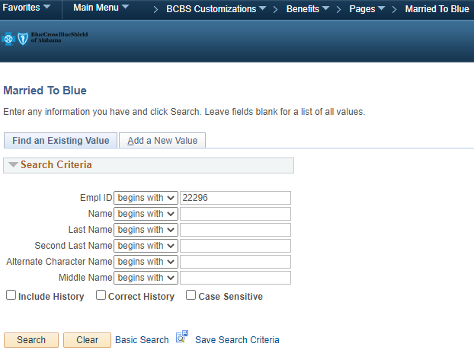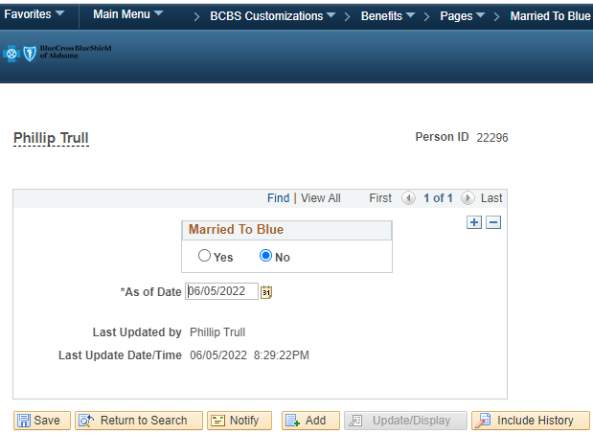

7. Disability